# Edge Delivery Services Workshop #1: Columns Block Styling

## Scenario

As a developer handling a lift-and-shift migration of a customer's site from their current CMS to Edge Delivery Services, you are tasked with analyzing and replicating a column page element from the homepage.

## Reminders

Use Google Chrome or a Chrome-based browser.

## 1. Review the existing column block

In this step, you will use Boilerplate blocks to construct existing content.

Navigate to https://main--ensembledotcomafter--ensemblesc.aem.live. Scroll down to the photo of Vancouver.

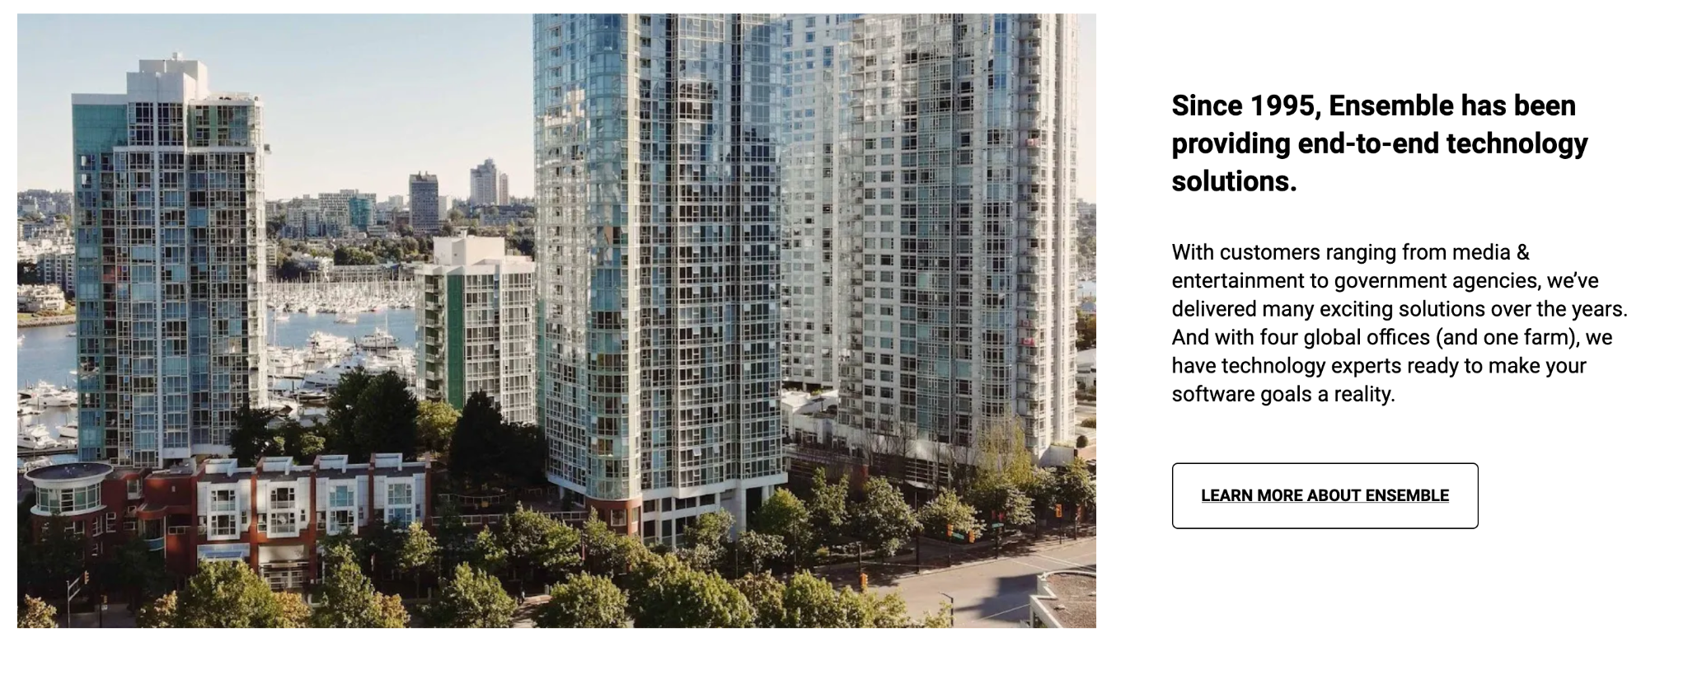

This is the piece from which you need to harvest the CSS.

Using your knowledge of the available blocks, you have determined that the best way to break down this set of page elements is as follows.

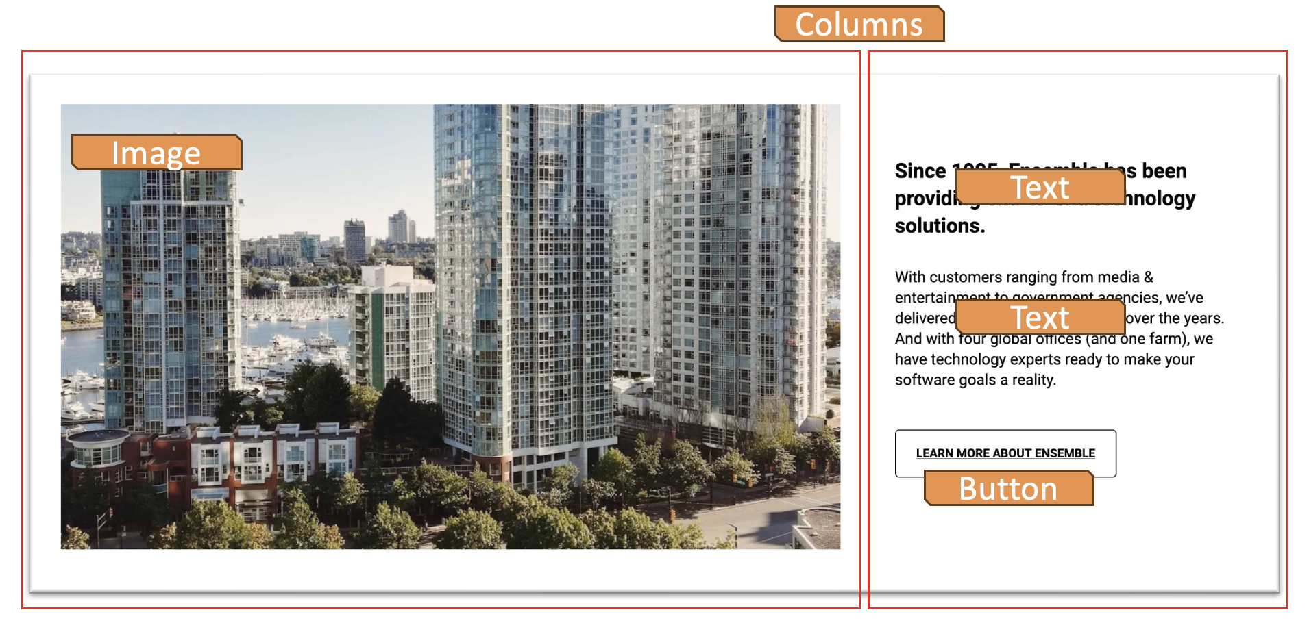

## 2 Clone code repository

In this step, you will prepare a code repo using a GitHub Template. You will have full control over this repo. Normally, you will start with the AEM Boilerplate which is what you did when you set up your machine. For this exercise, you will be starting with a repo based on the AEM Boilerplate and that has some of the Ensemble site built out already.

Navigate to <https://github.com/EnsembleSC/ensembleDotCom> and log in if you are not already logged in.

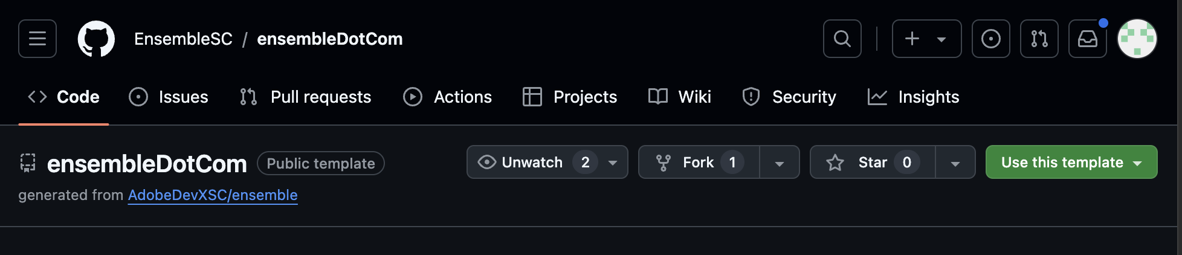

Click the Use this template button. Select Create a new repository.

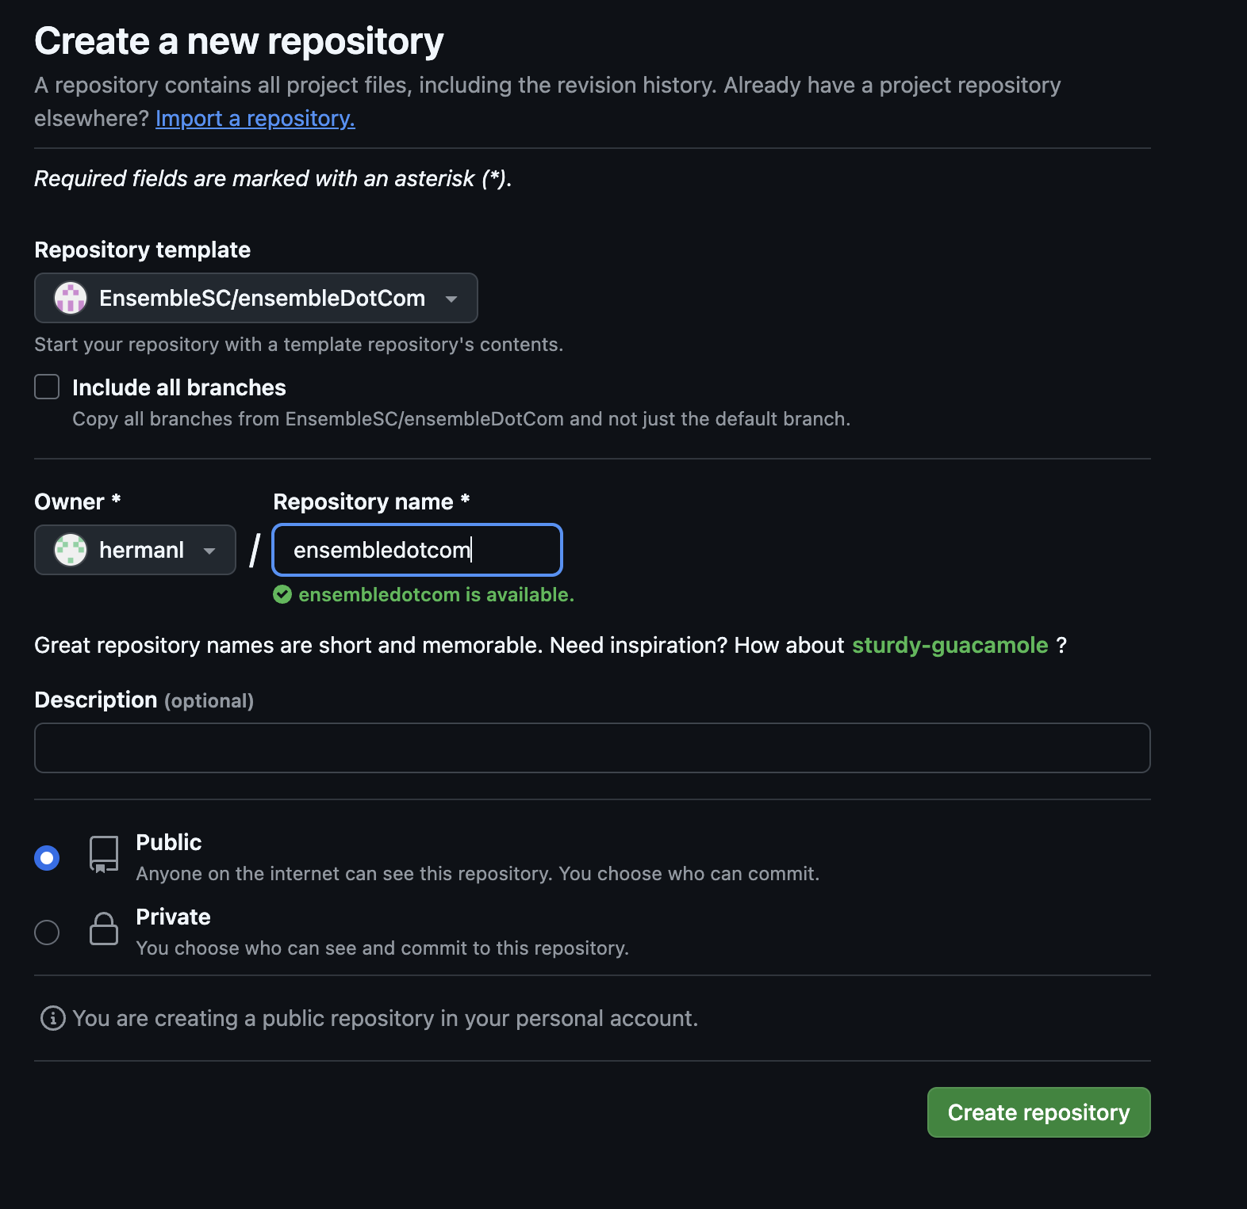

Set the repo to Public.

Name the new repo ensembledotcom. Create the repository.

## **3** **Download Code Locally**

In this step, you will download a copy of the code onto your computer.

Open Visual Studio Code and click on the Source Control icon located on the left rail.

If you see the Clone Repository button, then your computer does have Git installed and you may skip the steps to install Git.

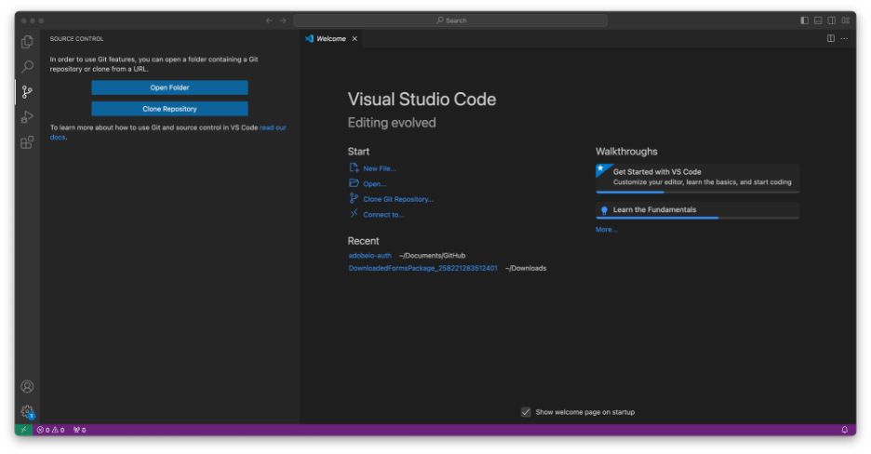

Click the Clone Repository button and paste the URL of your GIthub repo into the field.

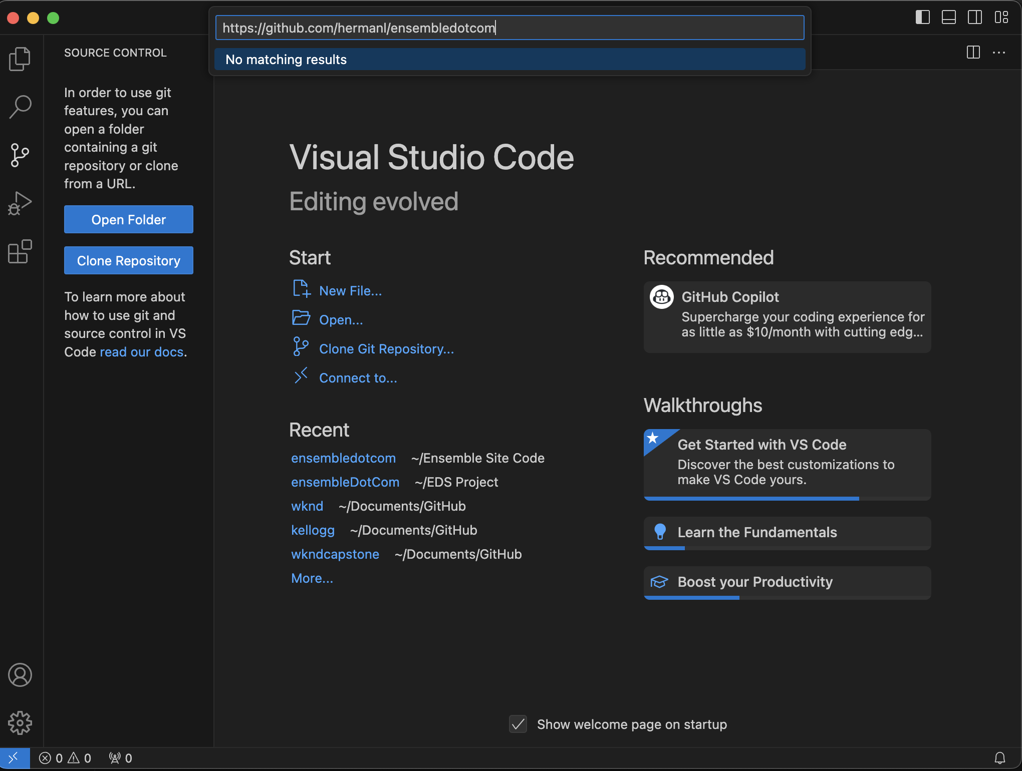

It should be <https://github.com/><username>/<repo name>. In the example above, it is <https://github.com/hermanl/EDSworkshop>.

Select a location on your computer to save your code base.

Once completed, you should see that your files are loaded in the Primary SideBar.

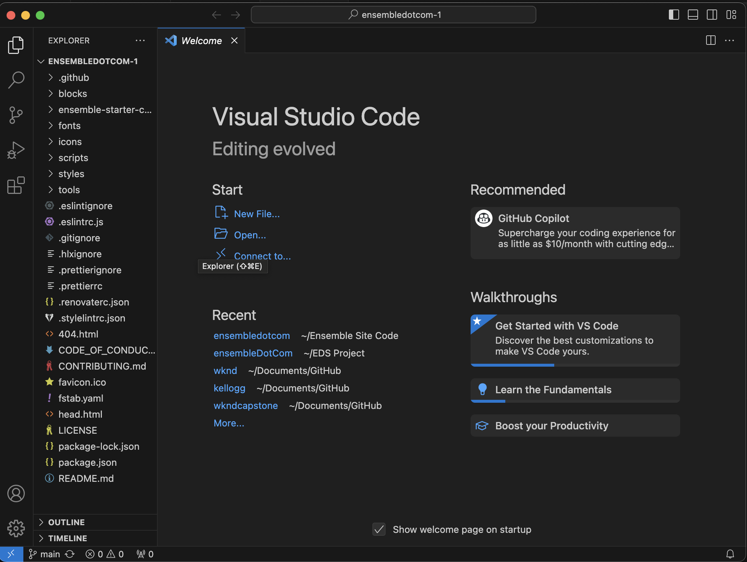

## 4 Update the README.md file

In this step, you will update the README.md so that you have a convenient place to locate them.

In Visual Studio Code, open the README.md file. Update the preview and live environment URLs. Save.

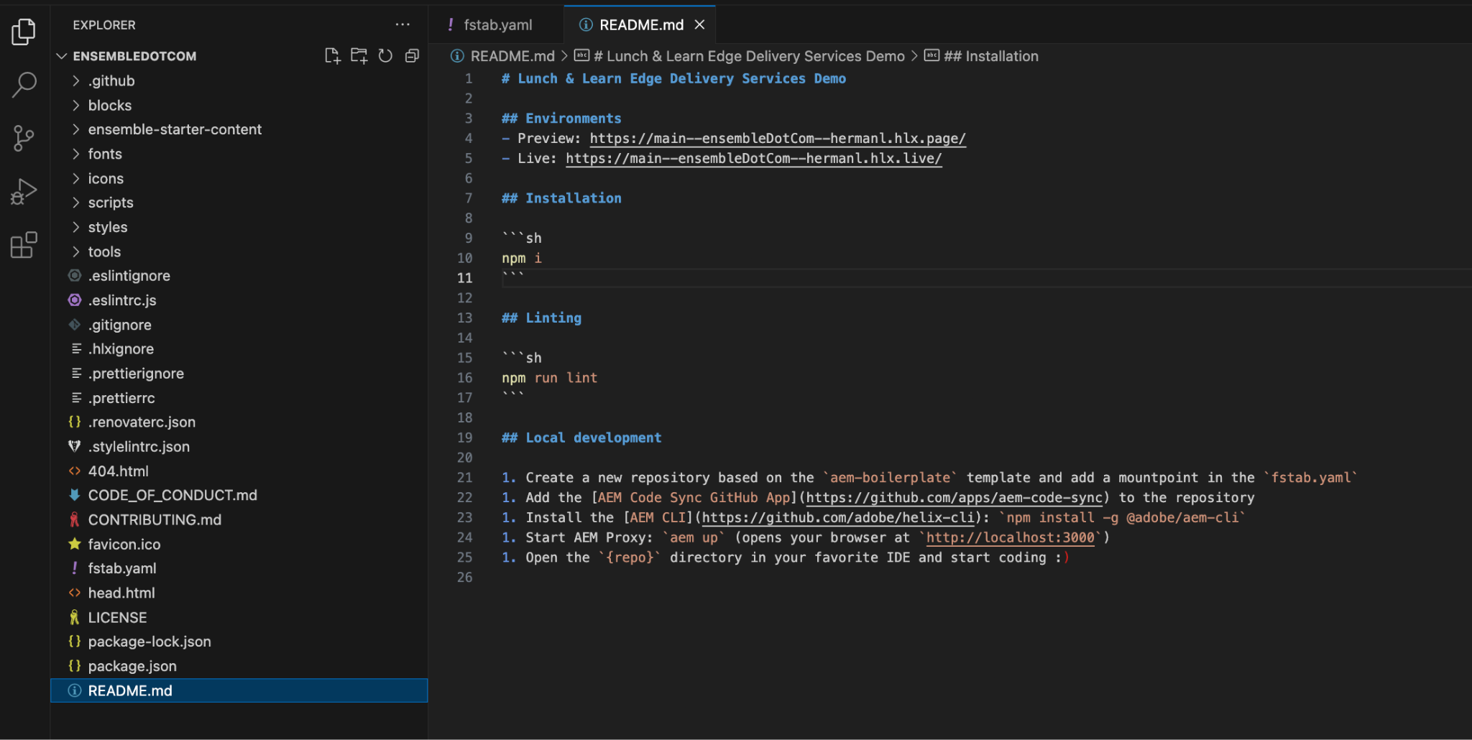

You should only need to change the the GitHub Username part of the URLS.

Preview: https://main--ensembledotcom–<your Github Username>.aem.page/

Live: https://main--ensembledotcom–<your Github Username>.aem.live/

## 5 Update fstab.yaml

In this step, you will link your Content Source folder on SharePoint to your code by adding the Content Source Folder URL into your code. You do this by changing the reference in fstab.yaml in your GitHub repo to the folder you just shared.

In Chrome, navigate to your ensemble folder. Use the Copy Link button to copy the link of the folder. Keep this handy.

Open your codebase in Visual Studio Code. Open the fstab.yaml file.

Replace the existing URL with the link. This link should open to the folder that contains the prepared content files on Sharepoint. By doing this, you are instructing the code where to find the folder that houses all the document-based content for the site.

Next, you will commit the change to the Github repo. Select the Source Control button in the left rail.

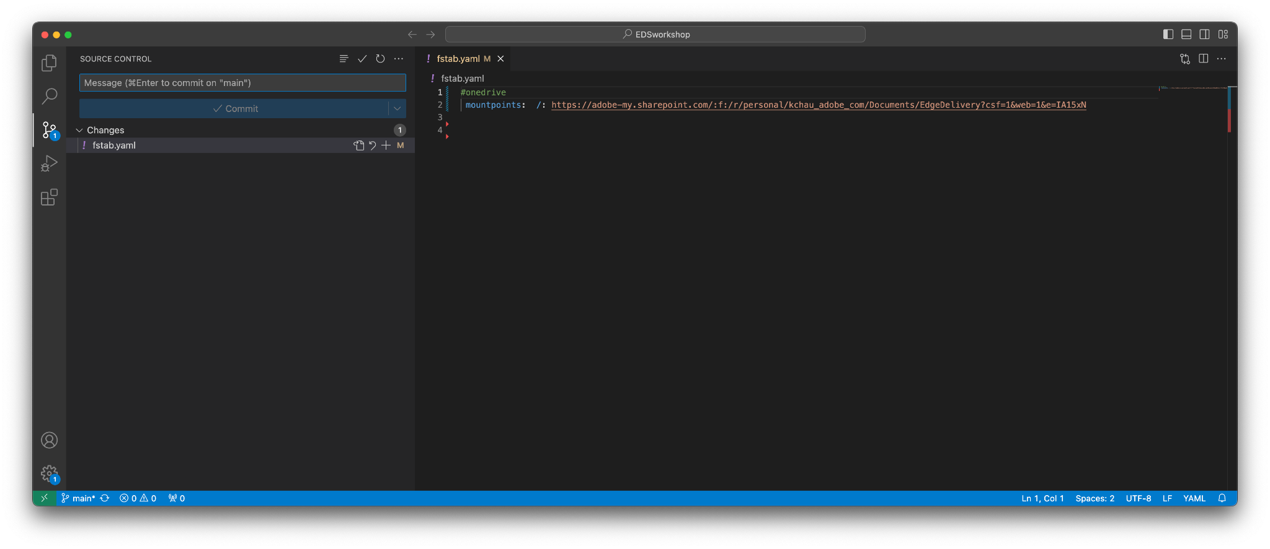

The next set of steps may differ depending on how your settings are.

Select the + button to the right of the fstab.yaml row. Enter a git commit message such as “Updated to point to SharePoint” into the field. (You cannot commit without providing a message)

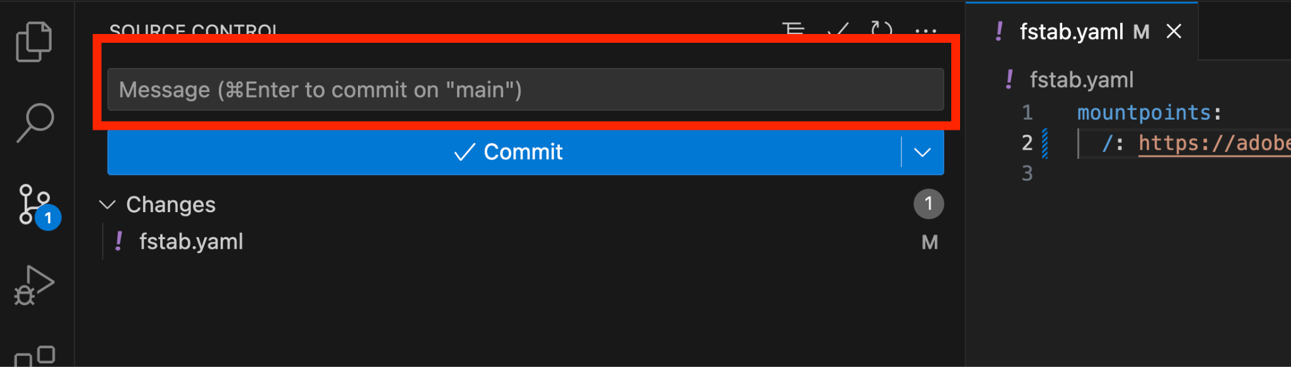

Select the Commit button.

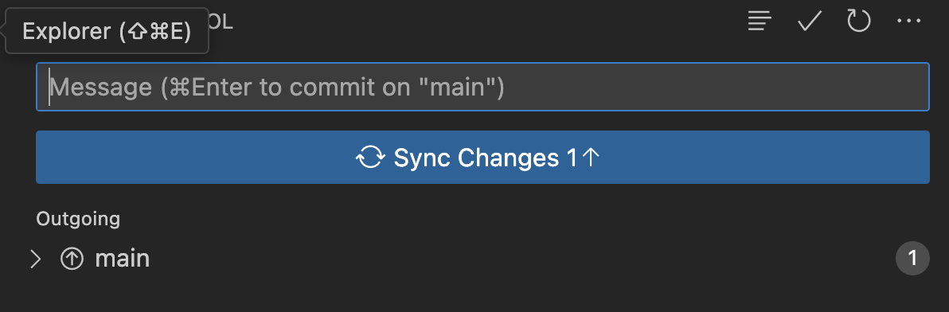

Enter a git commit message such as “Updated to point to SharePoint” into the field.

Select the Sync Changes button.

## 

## 6 Install the AEM Code Sync GitHub App

In this step you will link the code repo to Edge.

Install the AEM Code Sync GitHub App on your repository by visiting<https://github.com/apps/aem-code-sync/installations/new>.

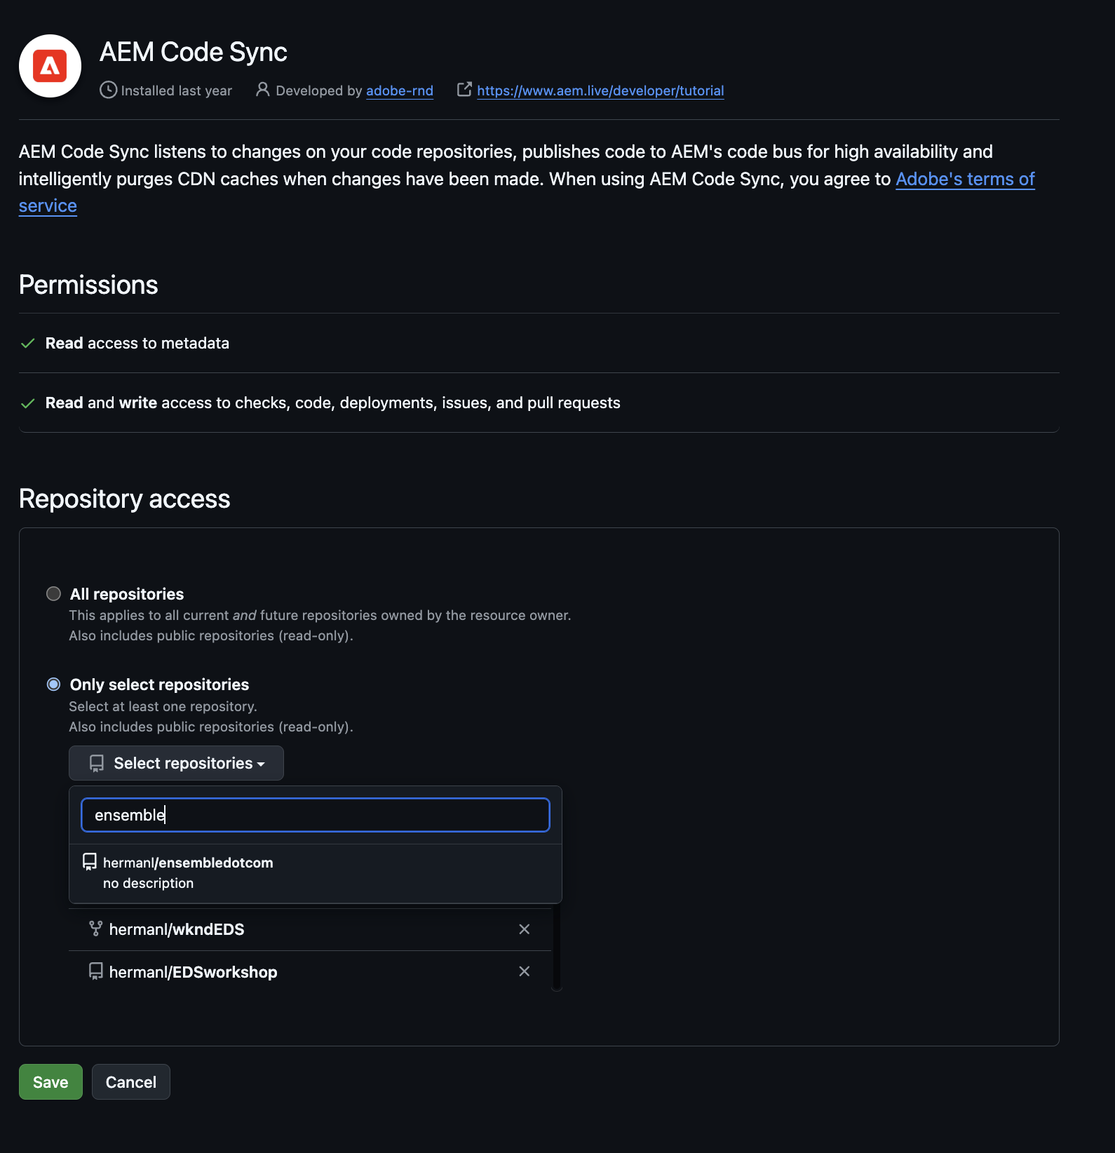

In the Repository access settings of the AEM Code Sync App, make sure you select "Only select repositories" (not "All repositories"). Then select your newly created repository, and click Save.

A new website is now running on https://<branch>--<repo>--<owner>.aem.page/ You will determine this URL based on your git repository.

<branch> = “main”  
<repo> = name of your git repo (all lower case)  
<owner> = git account user name

## 

## 7 Create folder for the site in SharePoint

In this step, you will create a folder on Sharepoint to hold the documents (site content) for your new site.

Sign into Sharepoint <https://adobe.sharepoint.com/:f:/r/sites/AEMNAMExpertSCs/Shared%20Documents/Web%20Foundation%20Training?csf=1&web=1&e=Mn8Xod> using your Adobe Credentials.

This SharePoint site was created specifically for this workshop. Inside, you will find a folder named after your user ID. This is where you will create additional folders to store your document-based content. If you don't see a folder already created for you, create one yourself.

Create a content source folder for the site’s content within the folder named after your user ID. Name the folder ensemble.

Note that technically this folder can be created anywhere within SharePoint but in practice, do not create it within another content source folder to avoid confusion.

Within the ensemble folder, create a folder called drafts.

## 8 Upload content to SharePoint

In this step, you will upload prepared content for the site into Sharepoint. This content bootstraps the creation of the site.

Access the files. The files are available at <https://adobe.sharepoint.com/:f:/r/sites/AEMNAMExpertSCs/Shared%20Documents/Web%20Foundation%20Training/hermanl/Workshop%201%20Content?csf=1&web=1&e=qixb1a>.

***Note: Please ensure that the filenames are in lowercase.***

You can use the "Copy to" option in SharePoint to copy the files into your folder.

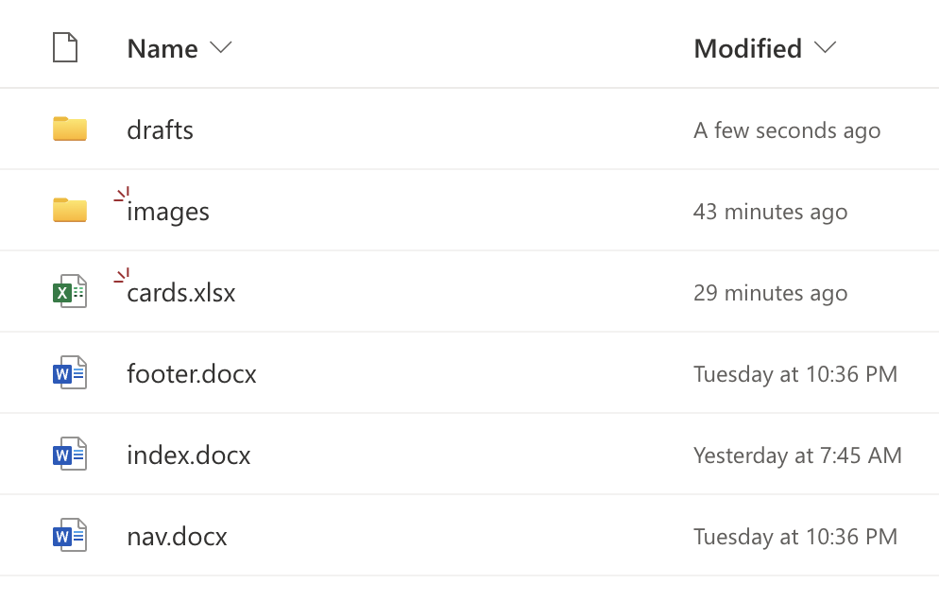

Navigate to your ensemble folder folder. Click the Share button and share the folder with [helix@adobe.com](mailto:helix@adobe.com).

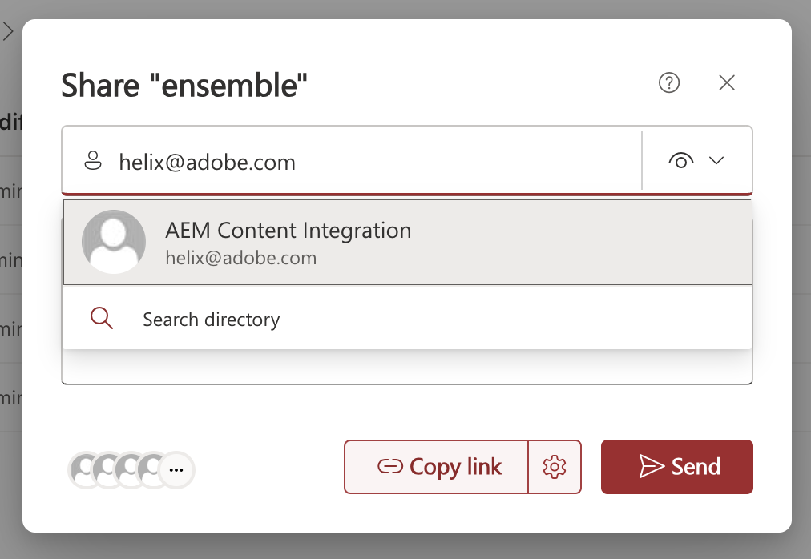

## 9 Preview Content

In this step, you will publish the existing pages to the inner CDN (*.page).

In Chrome, go to Github Repo. Right click on the AEM Sidekick and select add

Using the AEM Sidekick Extension, Add the project.

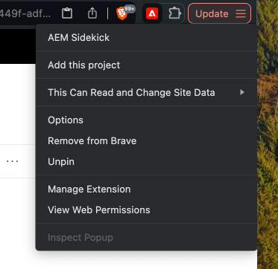

In Sharepoint, select all files and folder then select the Preview button in the Sidekick Extension This .pushes the content to a *.page URL.



## 10 Add draft content

In this step, you will create test content in the /drafts folder so you can test your code without affecting anything in production,

In SharePoint, open the drafts folder and create a new Word file. Name the file columns.docx. Open it.

Insert a 2 by 2 table.

Merge the two cells in Row 1 into one cell.

| Table | |
| --- | --- |
| Cells will be referred to as follows: | |
| CELL 1 | |
| CELL 2 | CELL 3 |

In Cell 1, add “Columns”. This tells EDS which block to use.

In Cell 2, add the image of Vancouver

| Table | |
| --- | --- |
| Copy and paste it into your document. | |

In Cell 3, add

| Table |
| --- |
| Since 1995, Ensemble has been providing end-to-end technology solutions.  With customers ranging from media & entertainment to government agencies, we’ve delivered many exciting solutions over the years. And with four global offices (and one farm), we have technology experts ready to make your software goals a reality.  [Learn More About Ensemble](https://www.ensemble.com/company) |

You should end up with this.

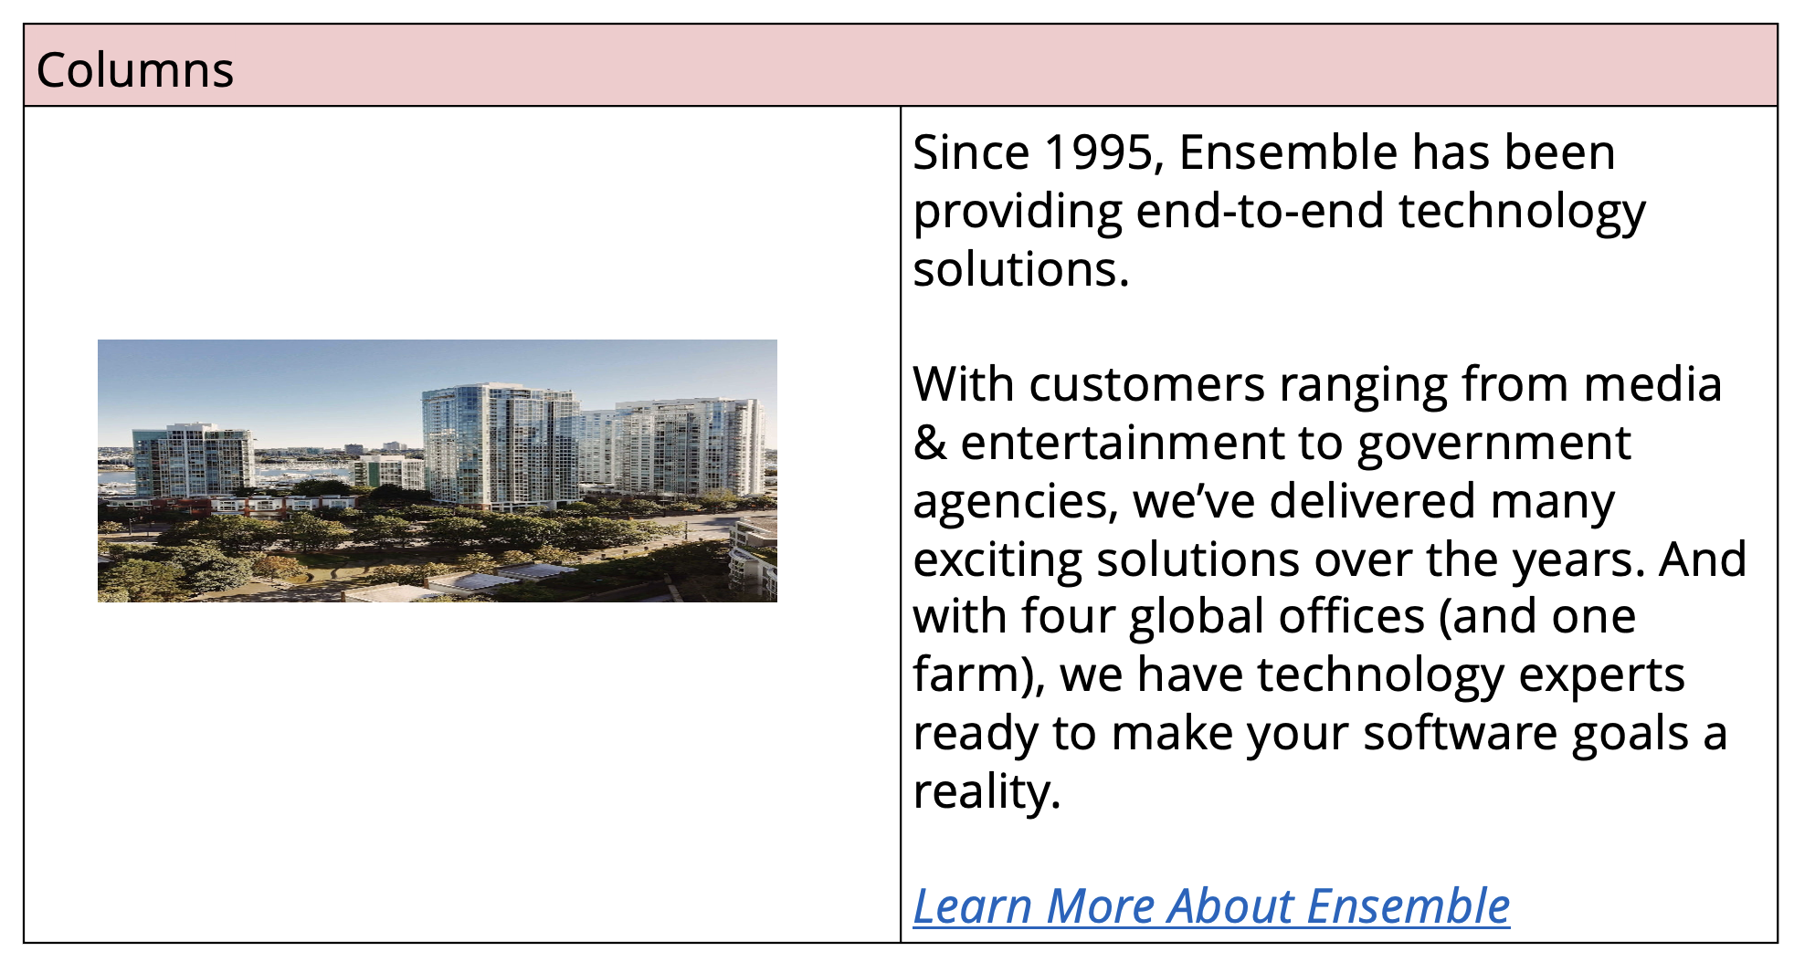

Note that the content inside each cell is important. The red shading for the header cell is only for decoration.

Preview this file using the AEM Sidekick.

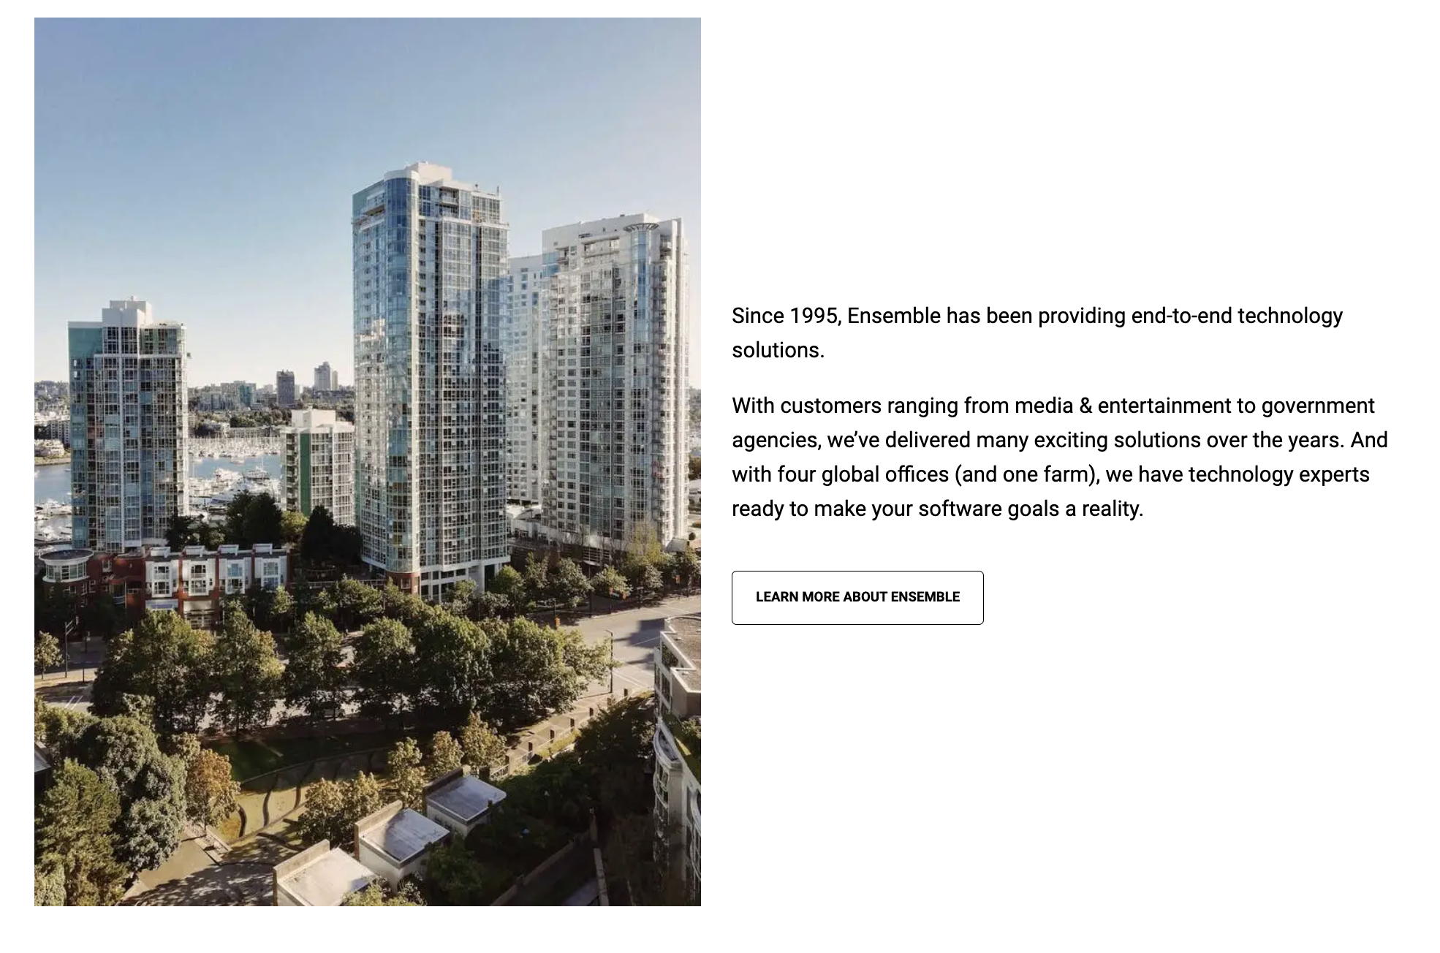

## 11 Start AEM Locally

In this step, you will start your local development environment.

Open your codebase in Visual Studio Code. Confirm that it is the right codebase by looking at the name in the center of the menu bar.



Bring up the terminal by selecting View from the menu then Terminal.

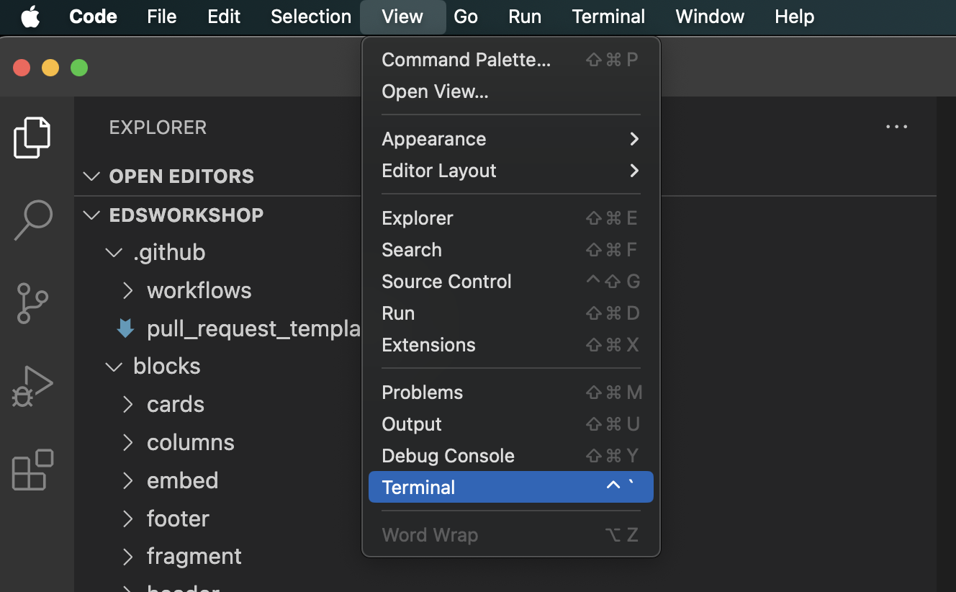

The Terminal panel should appear at the bottom of the window.

Type aem up into the terminal and press the ENTER key on your keyboard. This will turn on the tool.

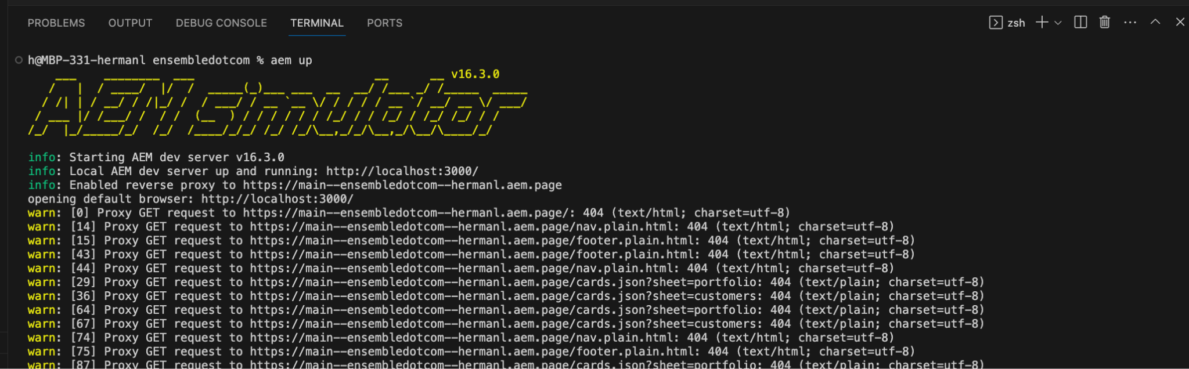

If the home page does not open, open [http://localhost:3000](https://localhost:3000) in Chrome.

## 

## 12 Examine the columns block files

In this step, you observe where code and assets go.

In Visual Studio Code, see that the code for a block goes into a /blocks/<name of the block> folder.

Code for a block is made up of a JavaScript file and a css file. The file “columns-default.css” exists for the purpose of this workshop and can be ignored by you. A result of organizing all files related to a specific block into a single folder is that block code is self contained or modular.

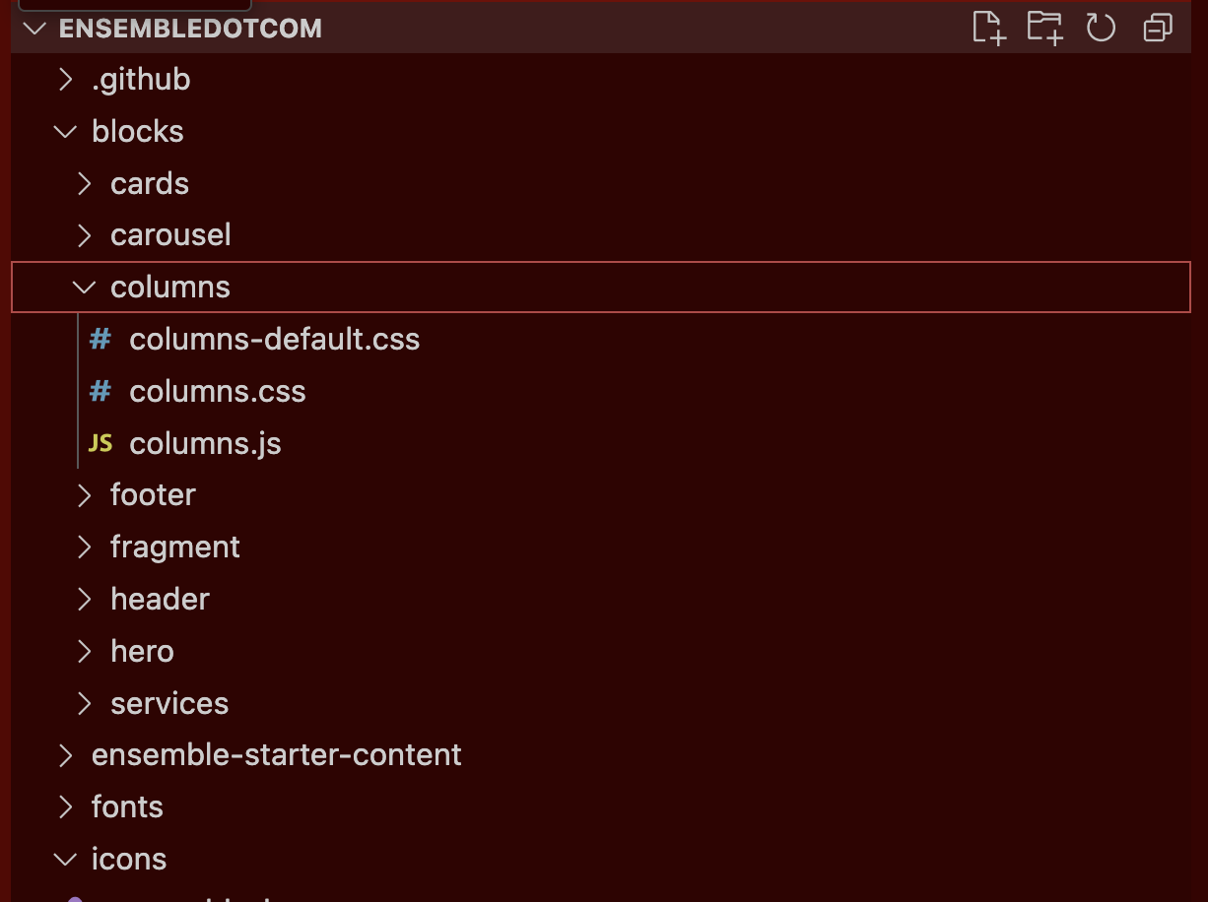

## 12 Use Inspector to compare styles

In this step, you will inspect the existing site to determine which css styles to copy and paste into your codebase.

The Inspector in Chrome, also known as DevTools, is a built-in tool that allows you to view and edit a webpage's HTML, CSS, and JavaScript in real-time. It helps with debugging, testing, and optimizing web pages.

In Chrome, navigate to https://main--ensembledotcomafter--ensemblesc.hlx.live. Scroll down to the photo of Vancouver.

Right click and select Inspect.

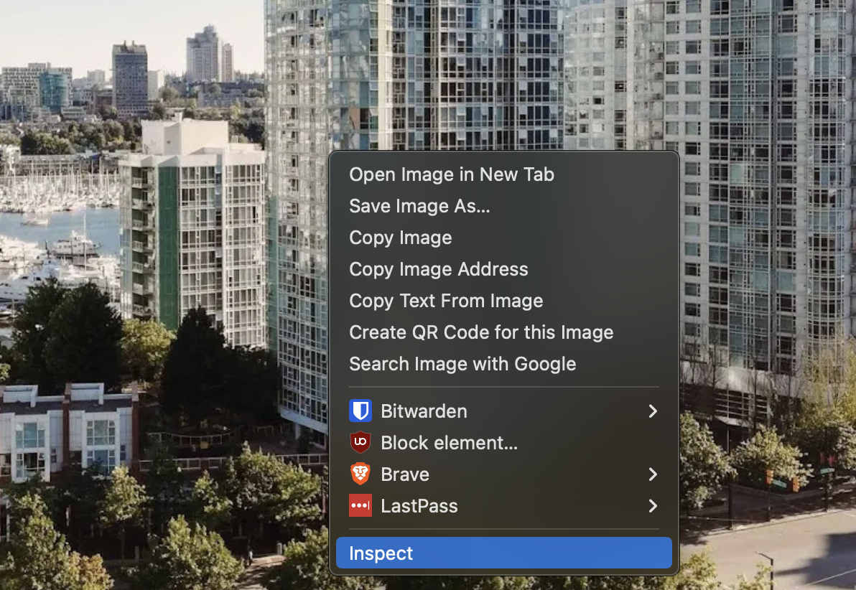

The Inspector in Chrome, also known as DevTools, is a built-in tool that allows you to view and edit a webpage's HTML, CSS, and JavaScript in real-time. It helps with debugging, testing, and optimizing web pages.

View the Styles tab in the Inspector.

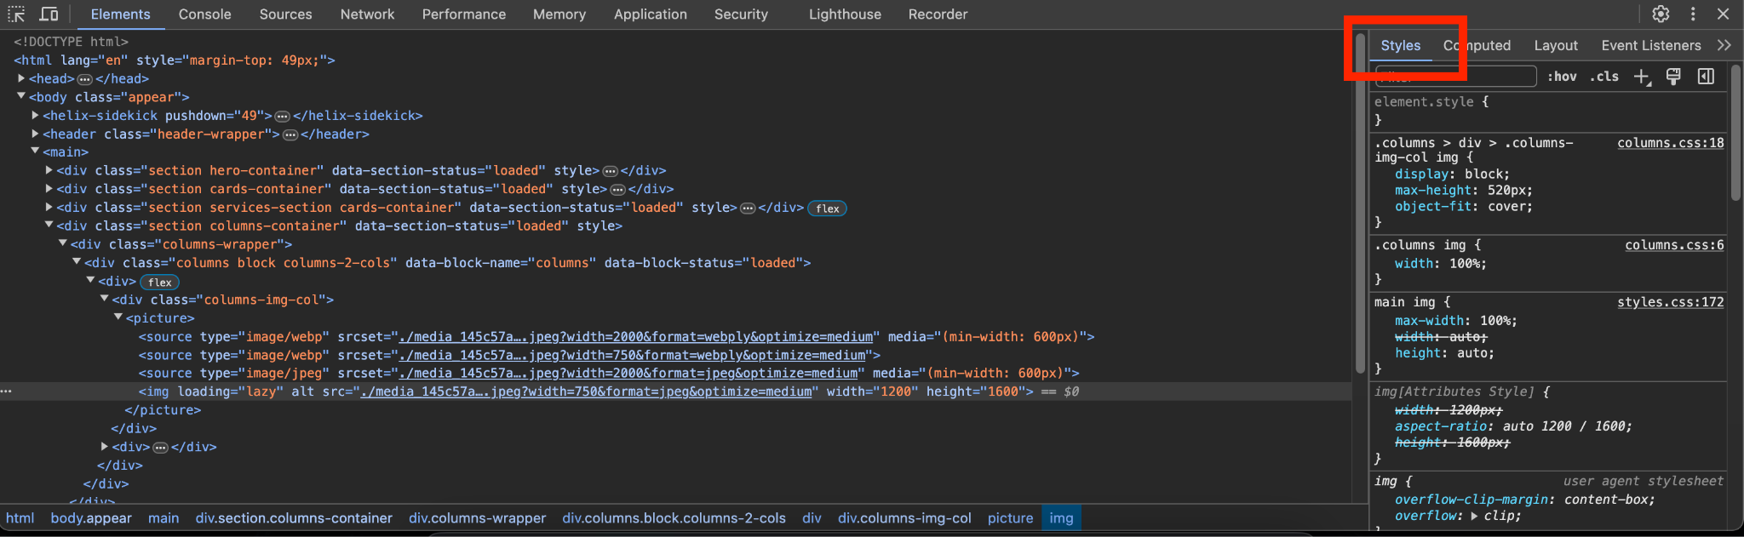

Visually, the image on the source site has a different aspect ratio compared to the one on your site. Additionally, note the variation in the portion of the image being displayed.

## 13 Update Image css for Images in Column Block

In this step, you will add css styles to your codebase which will make images in a Column Block look like the source version.

In Visual Studio Code, open /blocks/columns/columns.css and go to row 18.

Styles before:

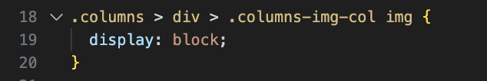

Copy and paste object-fit: cover; and max-height: 520px; from the Inspector in.

Styles after:

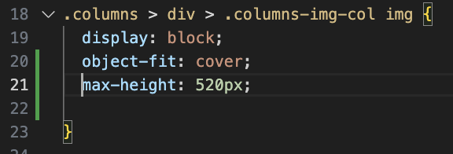

max-height: 520px; means that sets the maximum height of an element to 520 pixels. The element will not grow taller than this value, even if its content would normally require more space.

object-fit: cover; means that an image or video covers its container while maintaining its aspect ratio. The content is resized to fill the container, but parts of it may be cropped if the aspect ratios differ, ensuring there are no empty spaces.

## 14 Update First Paragraph css

In this step, you will add css to make the first paragraph look bigger and bold compared to subsequent paragraphs. You will also add styles that are dependent on the size of the screen.

Use the inspector to find the css styles that target the first paragraph.

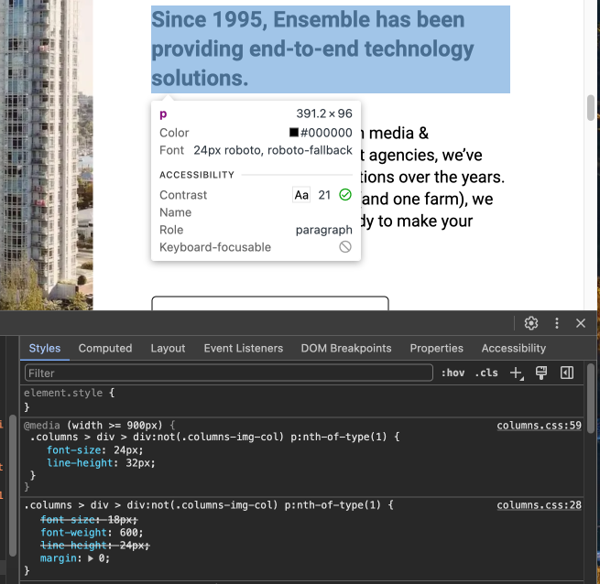

In Visual Studio Code, open /blocks/columns/columns.css.

First, add the default CSS styles. This applies when the screen is smaller than 900px wide.

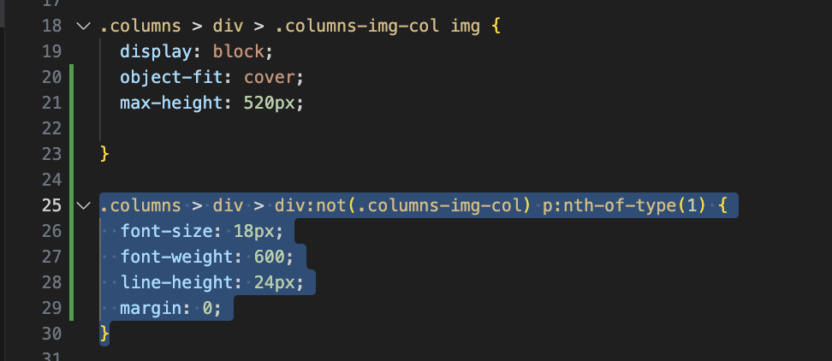

Next add the css styles for when the screen is 900px or wider.

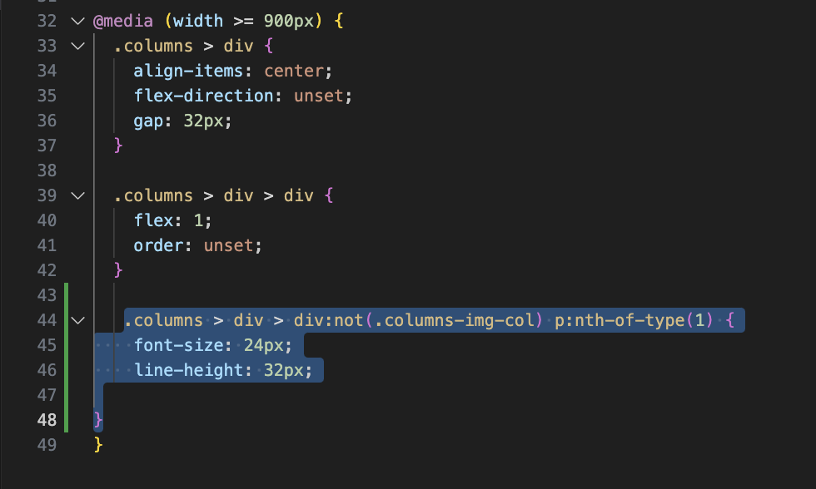

## 15 Update the css for Second Paragraph and Subsequent Paragraphs (Optional)

In this step, you will add css to styles the paragraphs from the second one onwards. You will also add styles that are dependent on the size of the screen.

Use the inspector to find the css styles that target the second paragraph.

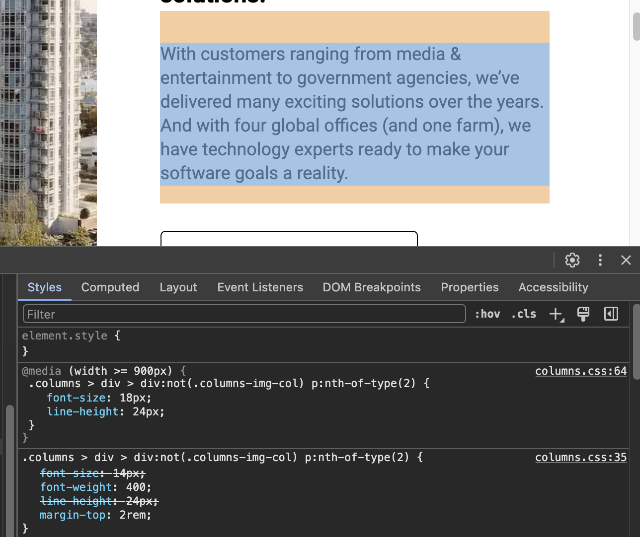

First, add the default CSS styles. This applies when the screen is smaller than 900px wide.

p:nth-of-type(2) targets the second paragraph within a parent element. Change the "2" to "n+2" so that the second paragraph and subsequent paragraphs will have the same style.

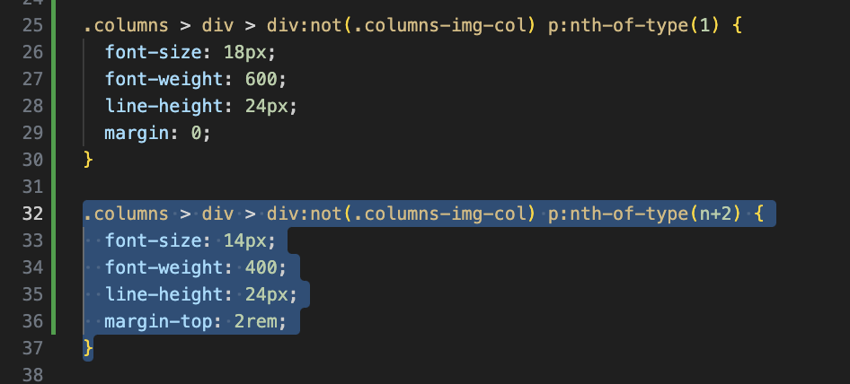

Next add the css styles for when the screen is 900px or wider.

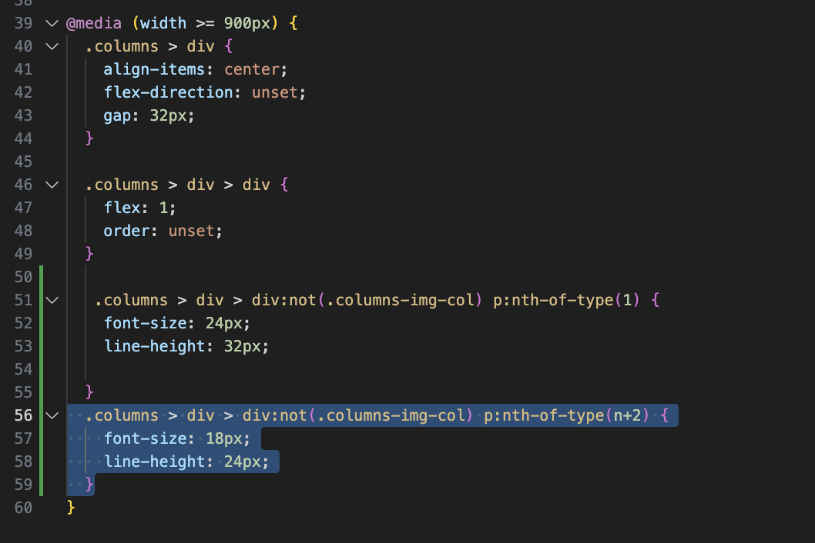

p:nth-of-type(2) targets the second paragraph within a parent element. Change the 2 to n+2 so that the second paragraph and subsequent paragraphs will have the same style.

## 16 Look at the Draft Page Locally

In this step, you will confirm whether the css styles just added by you are working?

In Chrome, navigate to <http://localhost:3000/drafts/columns>.

If it does not look like the source page, double check the styles in /blocks/columns/columns.css are correct and formatted properly.

To troubleshoot further, compare your css file to [column.css reference](https://adobe.sharepoint.com/sites/AEMNAMExpertSCs/Shared%20Documents/Forms/AllItems.aspx?csf=1&web=1&e=qixb1a&CID=e864a0fb%2D00ce%2D449f%2Dadf2%2D378696c58b61&FolderCTID=0x01200054B6454A880AB54DB6047A018D6198E0&id=%2Fsites%2FAEMNAMExpertSCs%2FShared%20Documents%2FWeb%20Foundation%20Training%2Fhermanl%2FWorkshop%201%20Column%20CSS&viewid=242a61b8%2D3aea%2D469e%2D9d9d%2D0248cc9bd690).

## 17 Add the Column Content to index.docx

In this step, you will add in your content to a live page.

In Chrome, open your index.docx. On page 3, you will find “INSERT COLUMN HERE”.

Replace “INSERT COLUMN HERE” with the Columns Table in drafts/columns.docx

Preview the page.

## 18 Add SVG Icon

In this step, you will convert an inline SVG into a SVG file and then insert onto your page.

Certain icons on websites can be in-line SVGs. There is not an easy way to download the icons as .svg files.

Navigate to <https://www.usbank.com/index.html> which uses inline SVGs.

Using the Inspector, examine the SVG icon of the money bag icon.

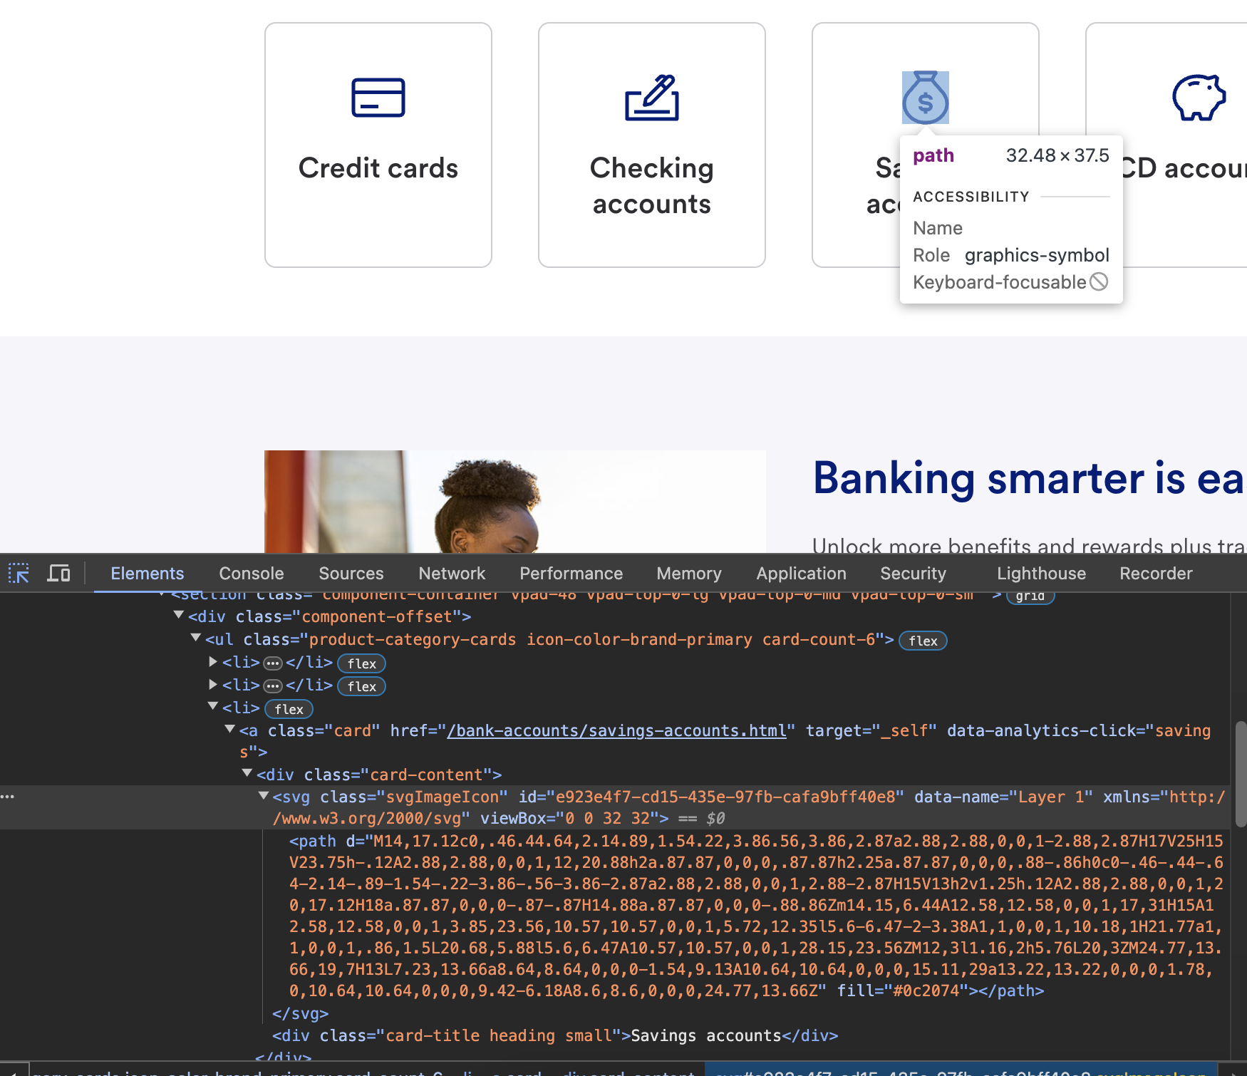

Copy the HTML for the money bag icon.

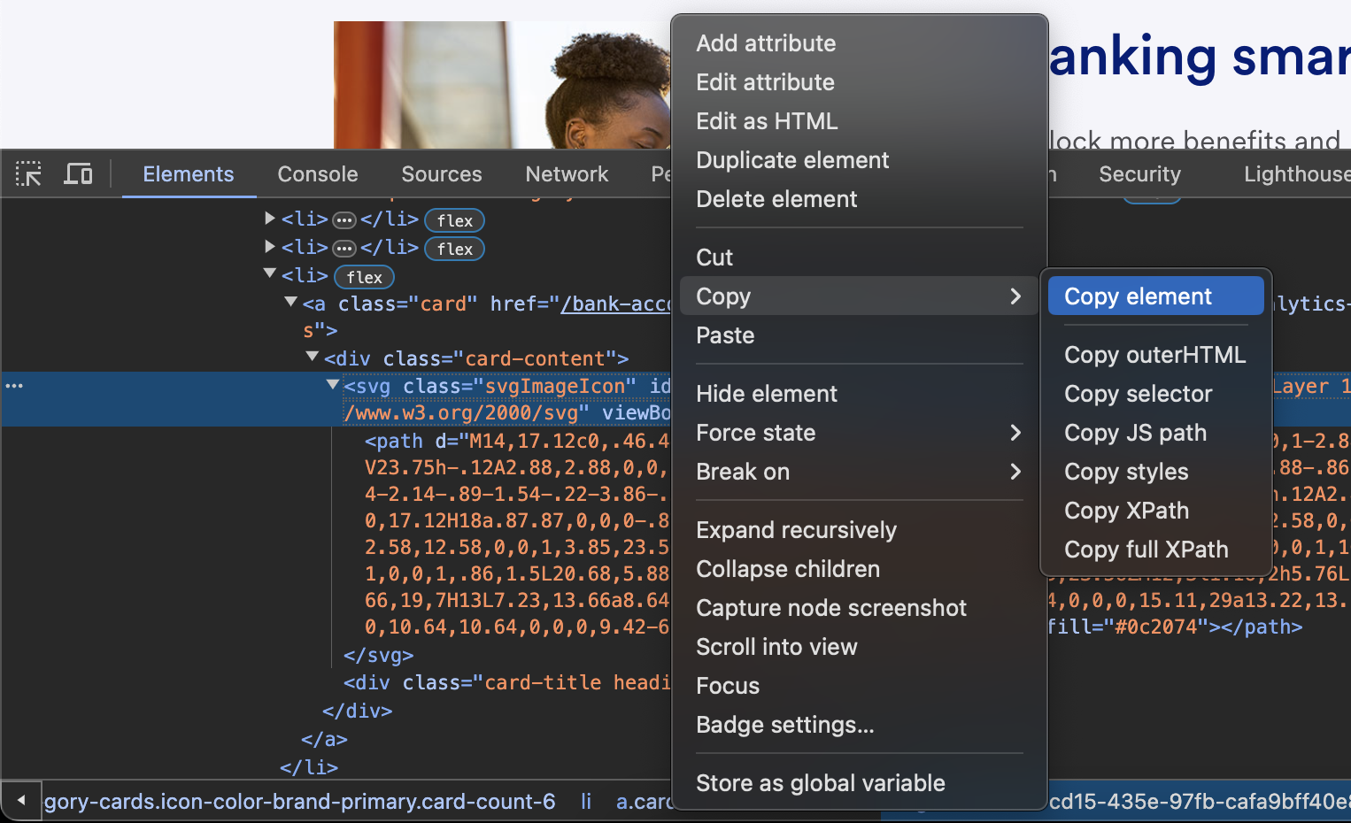

In Visual Studio Code, under the icons folder, create a new file called money.svg.

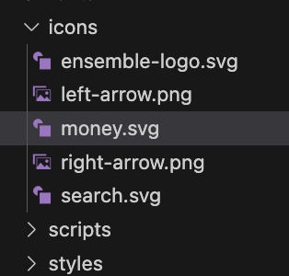

Paste in the copied HTML and save.

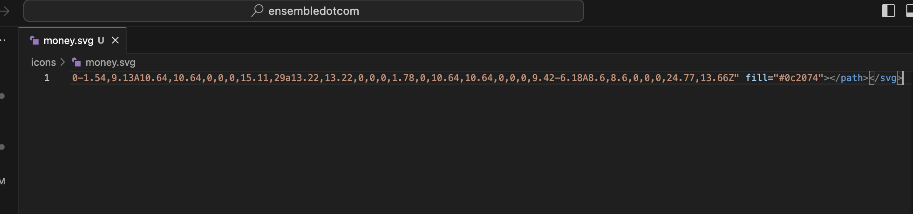

In index.docx, add :money: to the Columns table under the *Learn More About Ensemble* link. Note that icons can and should live with the content under an /icons/ folder. Icons are referenced using the :<iconname>: notation.

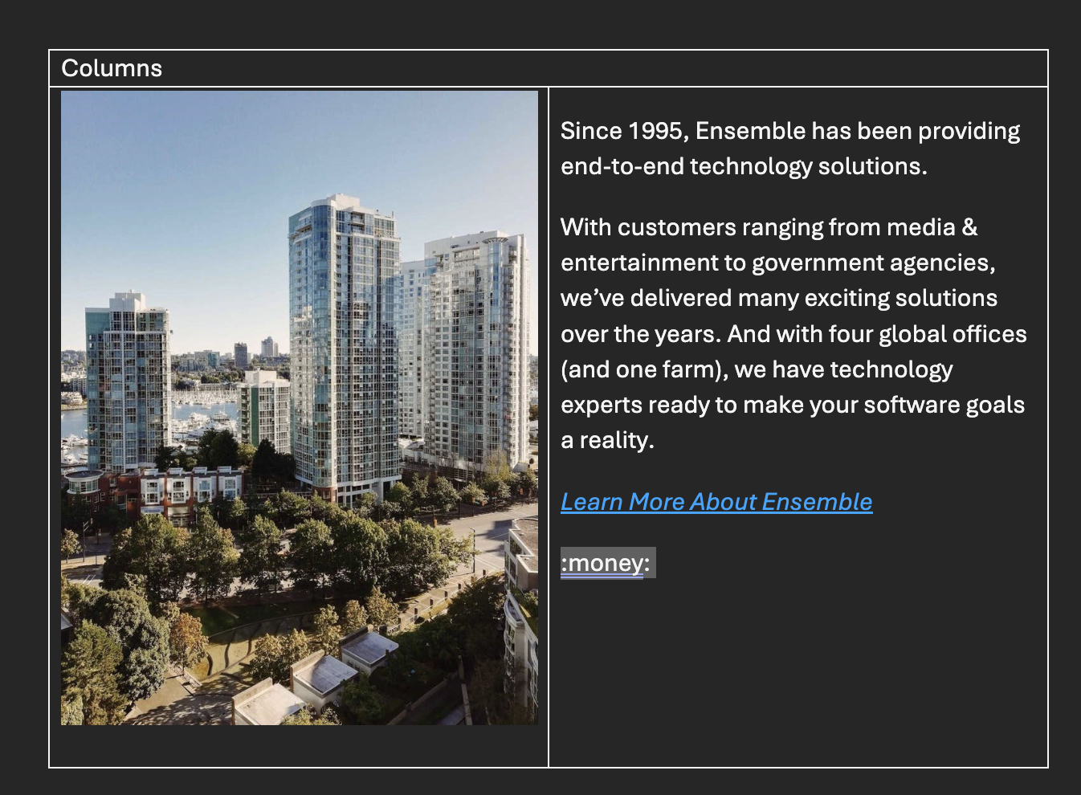

If you can download an SVG file, then simply add it to the icons folder. You will not need to use the HTML to create a SVG File.

## 19 Commit change

Once it all looks good locally, commit all changes.

.

## 21 Preview Content

Preview your index.docx page and view it at https://main--ensembledotcom–<your Github Username>.aem.page/.

## 22 Publish Content

Publish your index.docx page and view it at https://main--ensembledotcom–<your Github Username>.aem.live/